**ASSIGNMENT-4**

| Student Name | Sivashree K |
| --- | --- |
| Student Roll Number | 6113191031097 |
| Maximum Marks |  |

**1.Pull an Image from docker hub and run it in docker playground. Pulled** sandeepdoodigani/plasmaapplication and running in docker:

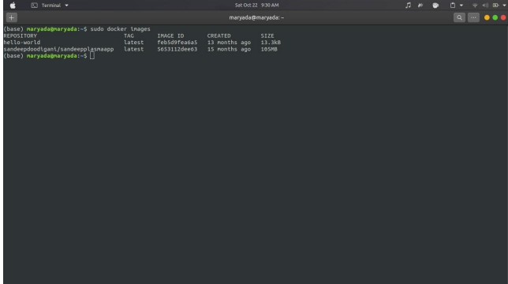

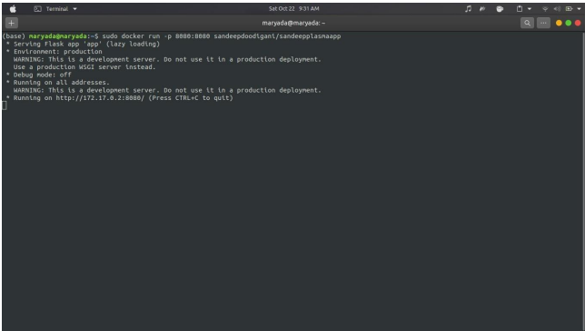

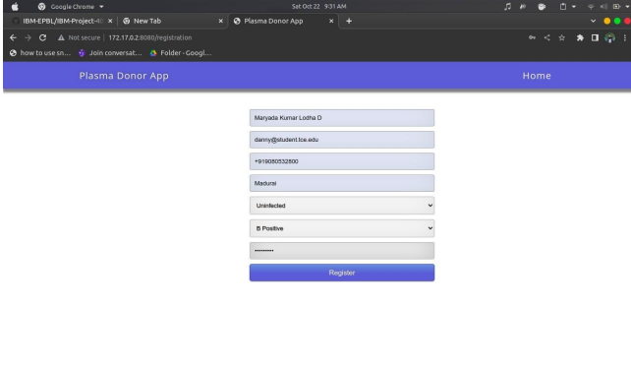

**2.Create a docker file for the jobportal application and deploy it in Docker desktop application. Dockerfile:**

**FROM python:3.6**

**WORKDIR /app**

**ADD . /app**

**COPY requirements.txt /app**

**RUN python3 -m pip install -r requirements.txt**

**RUN python3 -m pip install ibm_db**

**EXPOSE 5000**

**CMD ["python","app.py"]**

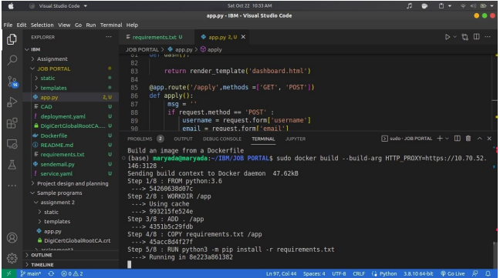

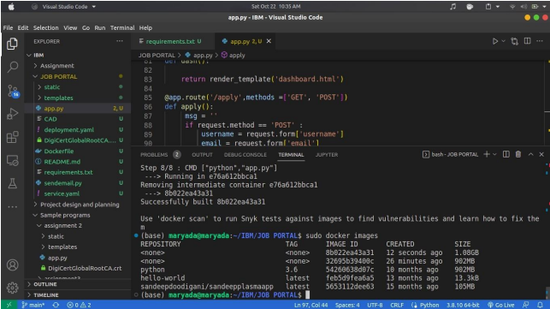

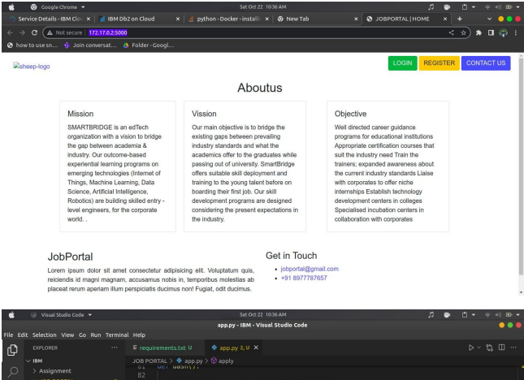

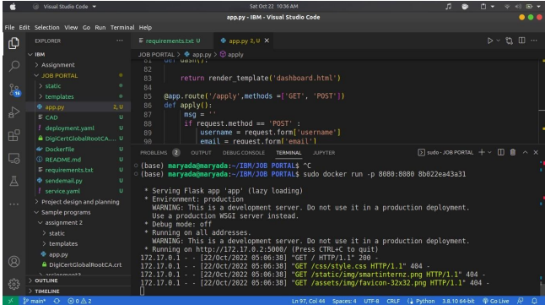

**3.Create a IBM container registry and deploy helloworld app or jobportalapp.**

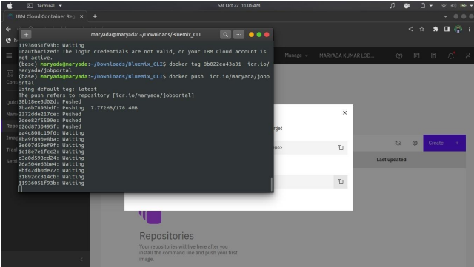

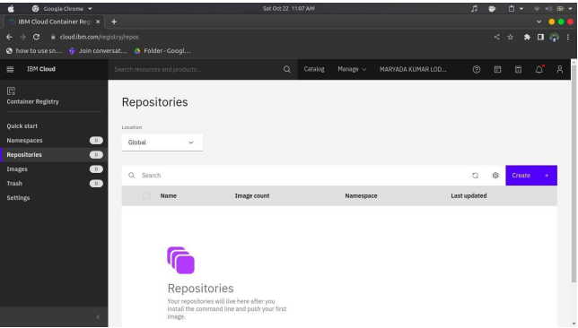

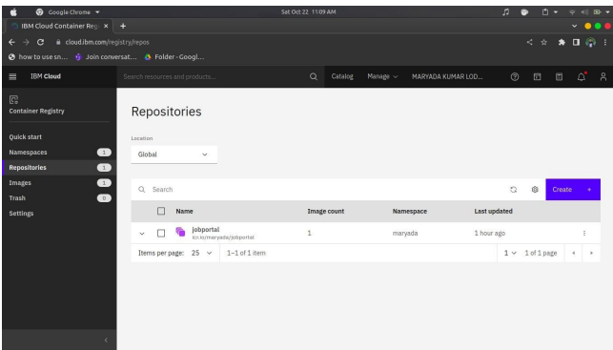

**4.Create a Kubernetes cluster in IBM cloud and deploy helloworld image or jobportal image andalso expose the same app to run in nodeport.**

